**USER MANUAL FOR THE LADYBIRD FOUNDATION WEBSITE**



Contents

Introduction 3

Getting Started 4

Registration 4

Login 5

Admin and User Functionality 6

Dashboard 6

UPCOMING EVENTS 6

User Page 7

ABOUT US 7

User About us Page 7

LOCATION 8

User Location Page 8

EDIT THE CONTACT PAGE 9

User Contact Us page 9

## Introduction

Welcome to the Ladybird Foundation's official website, a dedicated platform for raising funds and providing support to those who are less fortunate. The mission is to empower individuals and communities by addressing the immediate needs of the underprivileged, promoting sustainable development, and fostering a sense of community and shared responsibility.

This user manual is designed to guide you through the various features and functionalities of our website, ensuring that you can navigate and utilise it effectively. Whether you are a beneficiary, or simply someone interested in learning more about our cause, this manual will provide you with all the necessary information to make the most out of your experience with the Ladybird Foundation.

## Getting Started

### Registration

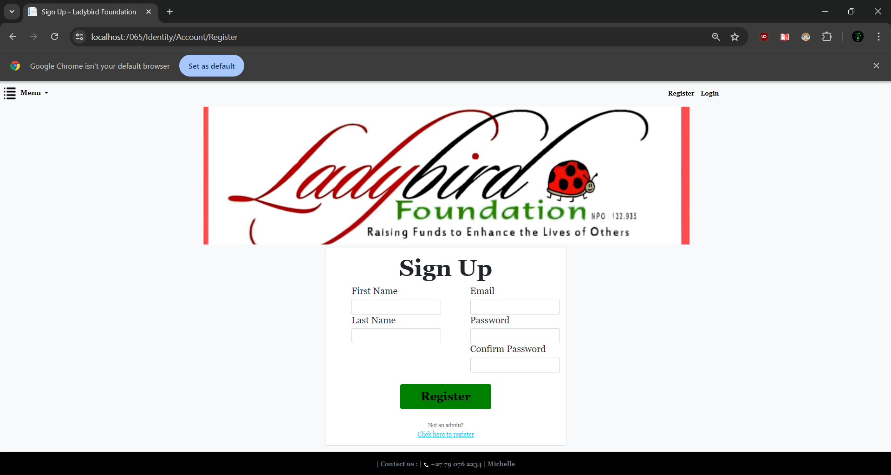

Users have the option of registering and logging into the website if they choose. The register and login functionality are required and prompted for the admins of The Ladybird Foundation Employees, so they can access the admin dashboard.

1. Register on the website: Click the registration tab at the top right of the screen.
2. Fill in Your Details: Enter your email address, create a password, and confirm your password and select your role.
3. Click register, and you will be a user on the Ladybird Foundation website.

### Login

As the registration function allows for a user to be saved to the database, the user can then use the credentials they entered while registering to login. This is the same for admins. Admins will have to select the admin role to have access to the dashboard.

1. Go to the Login Page: Click on "Log In" at the top right corner of the homepage.
2. Enter Your Credentials: Input your registered email and password.
3. Access Your Account: Click "Log In" to access your website functionalities.

## Admin and User Functionality

### Dashboard

Admin dashboard consists of multiple aspects.

### UPCOMING EVENTS

#### Admin Dashboard

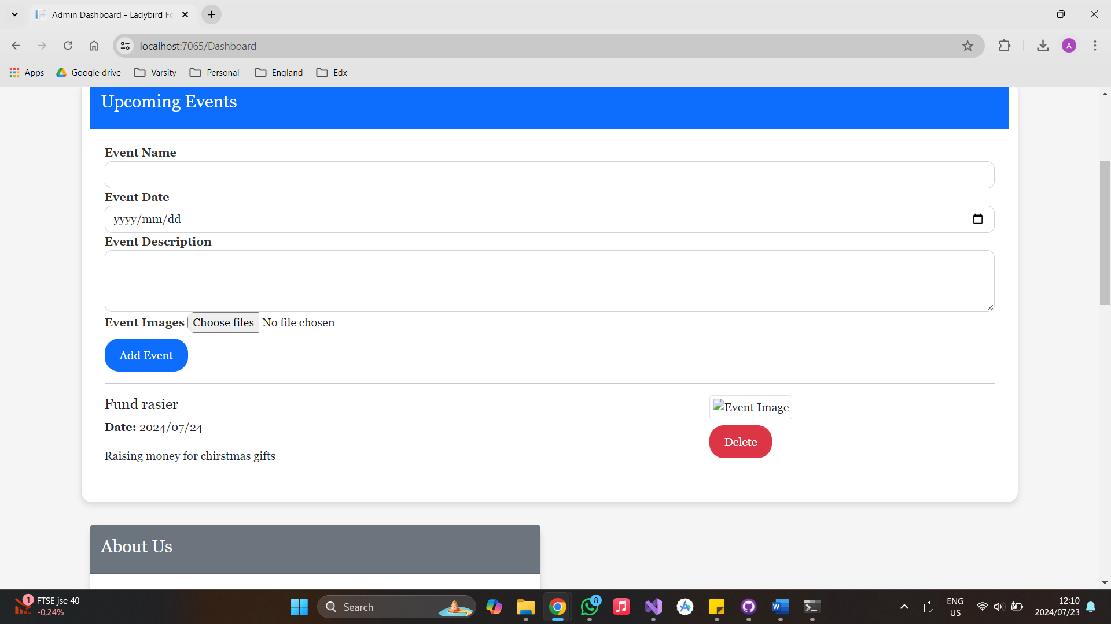

Admins can enter an event name, the date and a description, as well as an image which will all be saved to the database.

Once the admin has selected add event the event will be stored and displayed on the events page for the public to see.

### User Page

### ABOUT US

Admins will be able to enter the content and the company mission as well as an image and save it to the database.

This will then display on the about us page for the public to see.

### User About us Page

//Michelle has asked for 4 images which can be changed whenever. Please show this page once finished

### LOCATION

Admins will be able to add a new location if new drop off points are created for items to be donated. The admin will add a location name and the address and then add the location which will save to the database.

The locations are then saved to the database and displayed on the locations page with both the location name and the address.

### 

### User Location Page

### EDIT THE CONTACT PAGE

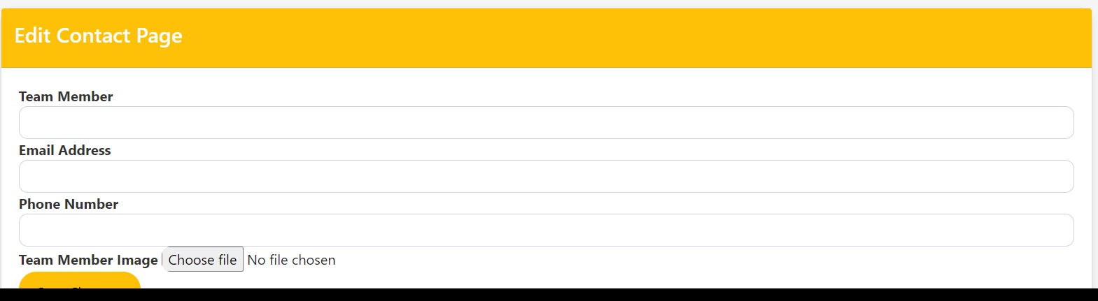

Admins can add team members, email address, phone number and an image of the team member.

They are then saved to the database, this is then displayed on the contact us page for the public to see and contact if need be.

### User Contact Us page

### FAQs

1. How do I reset my password? - Forgot Password: Click on "Forgot Password" on the login page and follow the instructions to reset your password.
2. Can I delete my account? - Delete Account: Go to "Settings", select "Account Settings", and choose the "Delete Account" option. Note that this action is irreversible.
3. How do I donate funds? – On the Donation page please contact Michelle for banking details, or use the banking details provided and in beneficiary reference add your name.